Performance Testing
Functional Testing of the Booking Module
Date | 28-10-2026
Team ID
Project Name | IMovies

Test cases
Test | Action | Expected result | Result
TC-1 | Open /api/movies in the browser while the server is running | JSON list of 6 movies from MongoDB Atlas | Pass
TC-2 | Open the home page | Movie cards with search box and genre filters are shown | Pass
TC-3 | Open a movie (Gravity Well) | Showtimes are grouped by day with time, screen, price and seats left | Pass
TC-4 | Open a showtime and select seats A1, A2 and A3 | Seats turn gold and the total shows 3 x 300 = 900 | Pass
TC-5 | Sign up, log in and confirm the booking | Ticket appears in My bookings with status Confirmed | Pass
Screenshot 1: API returns the list of movies (TC-1)
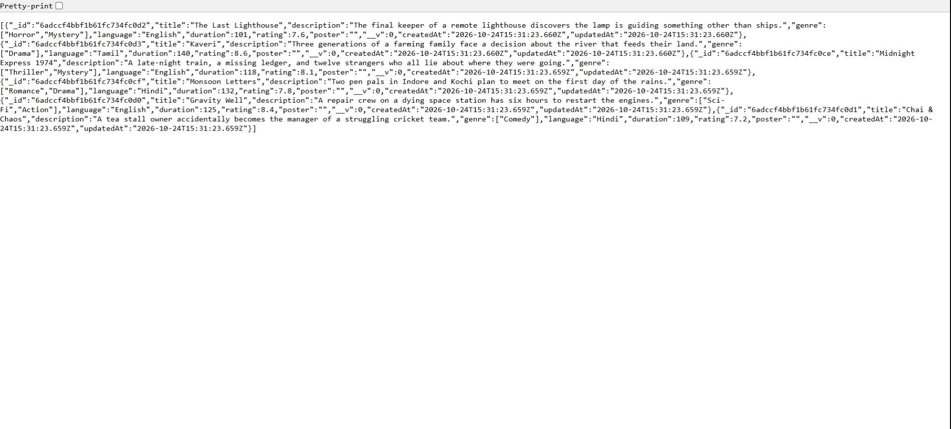
Screenshot 2: Home page with search and genre filters (TC-2)
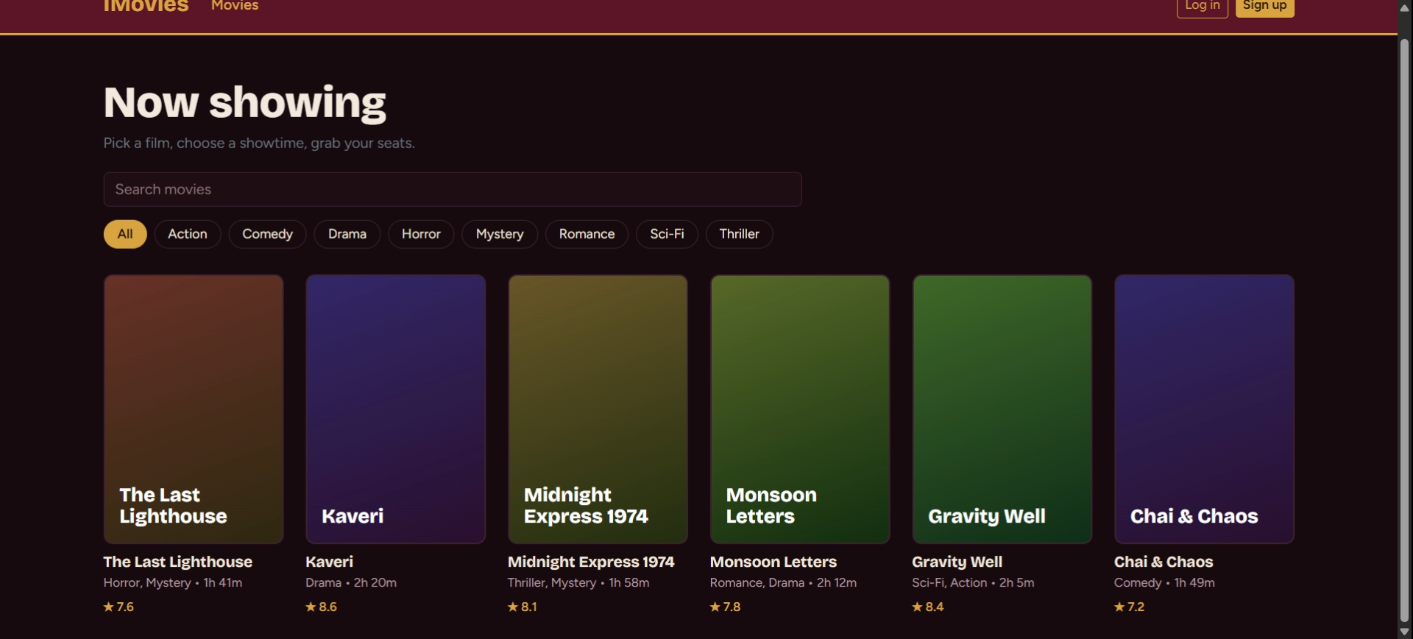
Screenshot 3: Showtimes grouped by day (TC-3)
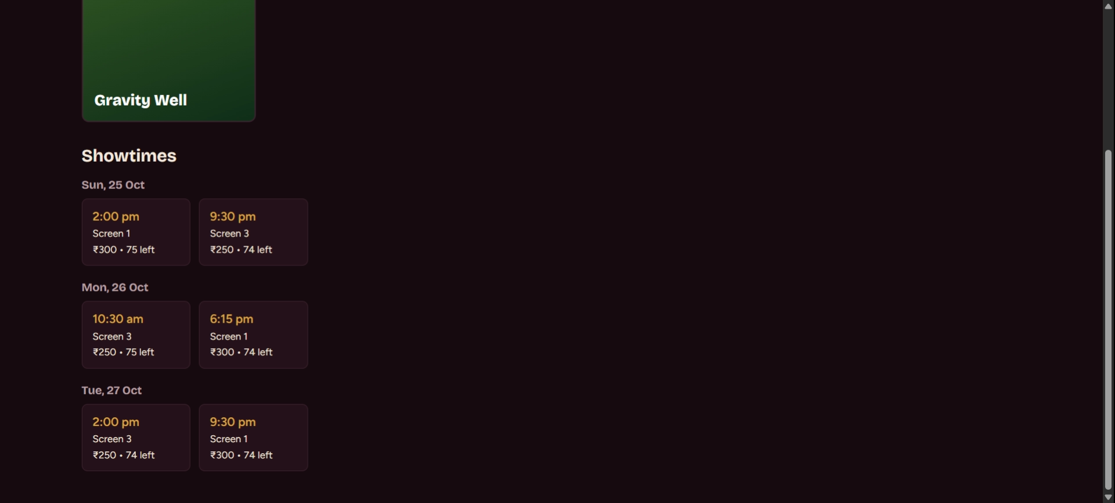
Screenshot 4: Seat map with 3 seats selected and total 900 (TC-4)
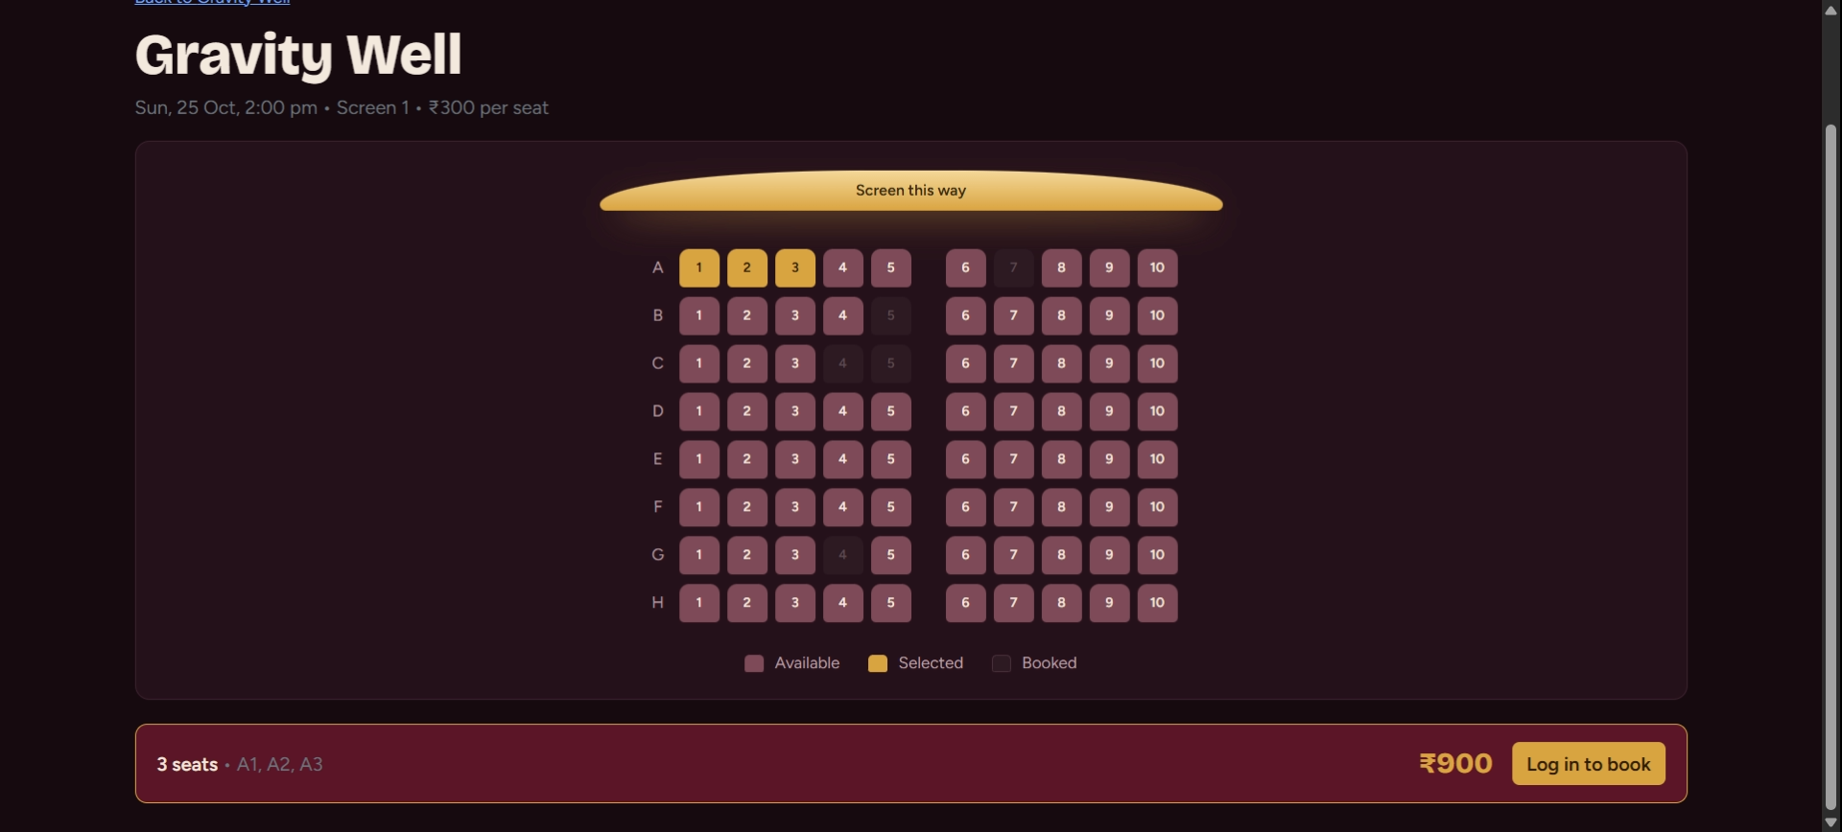
Screenshot 5: Confirmed booking in My bookings (TC-5)
